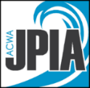
Sample Job Hazard Analysis
Lifting or Material Handling Exceeding 50 Pounds

NOISH recommends that repetitive lifting and materials handling not exceed 51 pounds. Occasional lifts up to 80 – 90 pounds occur in the water industry, but involve an increased risk of injury (90 pound jackhammers, bulk bagged materials, valves, etc.).

Use the following checklist to determine the increased risk of injury.
Does load, tool, or equipment to be moved/handled exceed 50 pounds? YES NO
Material/tool/equipment/weight to be lifted? _____________________________________
Is the load difficult to keep close to the body due to its shape, size, bulk? YES NO
Is footing or pathway unsafe (uneven ground, slippery, sloped)? YES NO
Does lifting/handling the load require bending, twisting, overhead reaching? YES NO
Does the task require more than four lifts to complete? YES NO
Will task take more than one minute to complete? YES NO
Will the task require traveling a distance or carry exceeding 25 feet? YES NO

If three or more of the questions are answered YES, an increased risk of injury is possible. The following options will be implemented to prevent injury and reduce risk. (Consider the use of more than one to reduce the risk of injury.)

- Discussion of risks and methods to be implemented to avoid injury with workers.
- Stretching before and after the task
- Material handling devices or equipment available (forklift, backhoe, auto crane, etc.)
- Specialized tools, PPE, or equipment (manhole bar, gloves, etc.)
- Dolly, cart, or wheelbarrow to be used
- Two-person lifts
- Breaking down the load/ordering smaller or lighter packages
- Increased housekeeping/provide a clear pathway
- Extra time/breaks to be provided for task, rest, and recovery.
- Other ________________________________________________________________
- Other ________________________________________________________________
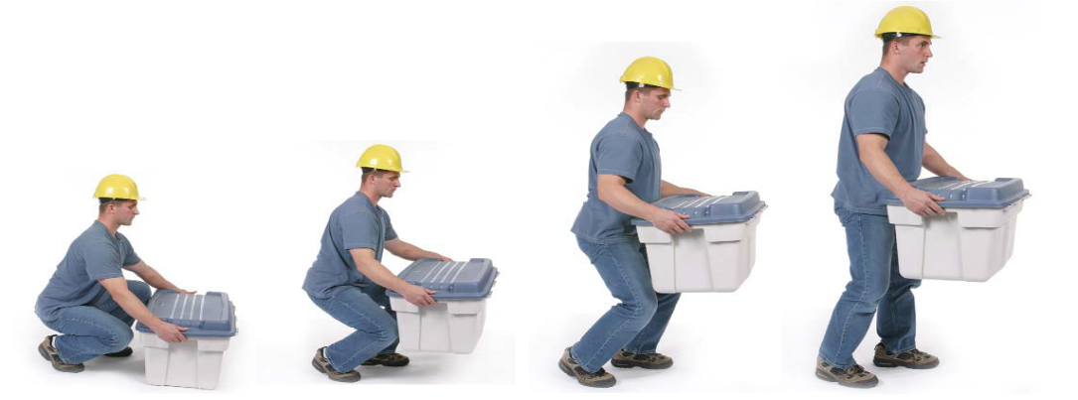
- Other ________________________________________________________________

