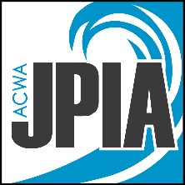

Visitor Symptom Check

Before Entering the JPIA Office

Before entering the JPIA office, all visitors are required to conduct a self-check for possible symptoms of COVID-19. Review each item listed by the CDC as symptoms and consider if you are suffering from any.

Do you have:
- Fever (100.4+) or chills
- Cough
- Shortness of breath or difficulty breathing
- Fatigue
- Muscle or body aches
- Headache
- New loss of taste or smell
- Sore throat
- Congestion or runny nose
- Nausea or vomiting
- Diarrhea

If you suffer from any of the above, you will not be allowed to enter the building. Thank you for keeping our staff and yourself safe and healthy.
People with COVID-19 have had a wide range of symptoms reported – ranging from mild symptoms to severe illness. Symptoms appear on average 4-5 days after exposure to the virus, but as many as 14 days.

