EMERGENCY RESPONSE GUIDE

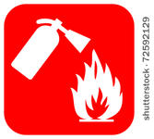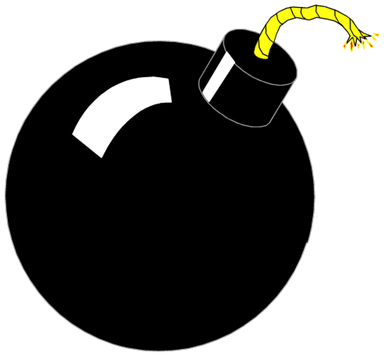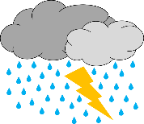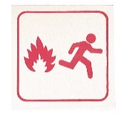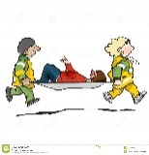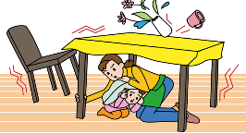

INTRODUCTION
ACTIVE SHOOTER, CIVIL DISORDER AND LAW ENFORCEMENT
MEDICAL EMERGENCIES
FIRE EMERGENCIES
BOMB THREATS
EARTHQUAKE/EXPLOSION | EMERGENCY OPERATIONS CENTER
CPR/AED
BUILDING EVACUATION | EMERGENCY NUMBERS
EVACUATION MAP

Indicates information that would need to be District specific if using this template

If an event occurs that threatens the safety of staff at YLWD or its visitors, dial 9-11. Do not assume you can handle situations on your own.
As a district employee it is important for you to be familiar with the information contain in this guide.

The health and safety code provides protection to individuals in section 1799.102 Which states “No person who in good faith, and not for compensation, renders emergency care at the scene of an emergency shall be liable for any civil damages resulting from any act or omission…” This is also referred to as the “Good Samaritan” law
This emergency response guide is designed for reference during emergencies such as fire, disaster, bomb threat or medical emergency. Keep this guide in a visible location so that it is readily accessible when needed.
TAKE TIME TO KNOW:
- Your exits and paths of egress
- Where your assigned Assembly Area is
  - Primary: Next to Warehouse
  - Alternate: Flagpole in front parking lot
- The location of the fire alarm manual pull stations (Building 1,2 and 4)
- Where fire extinguishers, first aid kits and automatic external defibrillators (AEDS’s) are located

INTRODUCTION

ACTIVE SHOOTER
HOW TO RESPOND: When an active shooter is in your vicinity. Quickly decide the most reasonable way to protect your life.
RUN  - Have an escape route and plan in mind  - Leave your belongings behind  - Keep hands visible | HIDE  - Hide in an area out of the active shooters view  - Block entry to your hiding place and lock the doors  - Call 9-1-1 when it’s safe to do so | FIGHT  - As a last resort and only when your life is in imminent danger  - Attempt to incapacitate the active shooter  - Act with physical aggression and throw items at the active shooter
HOW TO RESPOND AND REACT when law enforcement arrives on the scene
- Remain calm and follow officers’ instructions  - Immediately raise hands and spread fingers  - Keep hands visible at all times  - Avoid yelling, pointing or screaming | - Avoid making quick movements towards officers such as attempting to hold onto them for safety  - Do not stop to ask for help or directions when evacuating, just proceed in direction from which officers are entering the premises
INFORMATION TO PROVIDE TO LAW ENFORCEMENT
- Location of the victims and the active shooter  - Numbers of shooters if more than one | - Number and type of weapons held by shooter(s)

ACTIVE SHOOTER, CIVIL DISORDER AND LAW ENFORCEMENT

Civil Disorder
Report any acts of civil disorder to the Name of local Law Enforcement / Police Department. If it is necessary, dial 9-11. If it is not an urgent matter, contact Law Enforcement on a non-emergency line (see Emergency Numbers tab), notify your supervisor of the incident so Management is made aware. It may be necessary to keep employees in the building depending on the circumstances until an all clear is determined. Do not confront or antagonize a disruptive subject or situation.
When reporting:
- Speak slowly and controlled
- Report your name and title
- Report the location of problem
- State the nature of the problem
- Provide phone number where you can be reached

ACTIVE SHOOTER, CIVIL DISORDER AND LAW ENFORCEMENT

FOR ALL LIFE THREATENING EMERGENCIES, DIAL 9-11.
GIVE THE FOLLOWING INFORMATION
- What is wrong? (Shortness of breath, chest pains, sudden collapse or profuse bleeding, etc.)
- What, if anything, is being done? (First aid, CPR, evacuation, etc.)
- Your name
- Department Name
- Your Phone Number/Extension
- LOCATION: Building Address (insert addresses / building locations / etc )
- If necessary have someone meet the firefighter/paramedics at the street; guide them to the emergency site

FOR CARDIAC EMERGENCIES (HEART ATTACK) SEE CPR/AED TAB

MEDICAL EMERGENCIES

Discovering Fire, Smelling Smoke and Activating Alarm
- If a fire is discovered, utilize the nearest fire alarm manual pull station to activate the alarm system. This immediately notifies the occupants. The fire department will be notified through an automated system, but it is still necessary to dial 9-11.
- If you discover a small fire, utilize a fire extinguisher, if you’ve been trained.
- When the alarm sounds, evacuation procedures should begin immediately (See Building Evacuation)
- Feel the door that lead leads from your office to the corridor before opening it. If it is hot or smoke is seeping in, do not open. If you become trapped in your office, keep the door closed and put an article of clothing at the bottom of the door to minimize smoke infiltration. Call the fire department for rescue.
- If the door feels cool, open cautiously. Close the door immediately if the hall is smoke filled. If the hall is clear, proceed with the evacuation plan.
- If you are caught in smoke or heat, crawl under the smoke where the air quality is better. Take short breaths through your nose until you reach a safe area or exit.
- If you have to call the fire department: know the street address and building you are in.
- If you are trapped, stay calm. Describe your exact location. Stay on the telephone until the dispatcher tells you to hang up.

FIRE EMERGENCIES

- When a bomb threat is received by telephone, try to obtain as much detailed information as possible. Stay Calm.
- Do not upset the caller.
- Write down information as it is given.
Ask
- When is the bomb going to explode?
- Where is it located?
- What size and type of bomb is it?
- What does the bomb look like?
- Why was the bomb planted?
- Where is the caller calling from?
- Note the time of the call and extension it was received on, and any caller ID information.
- Make a note of the caller’s voice, accent, temperament, male or female, background noises, etc.
- Notify the Police Department and your supervisor immediately. They will determine if evacuation is necessary.
- Do not use radios, hand’s free devices, cell phones within 300 feet of the target location; these can cause a bomb to detonate.

BOMB THREAT

Earthquake  - Stay in the building. Watch for falling debris. Stay away from windows and mirrors.  - Crawl under a table or desk, duck, cover and hold on, sit or stand against an inside wall and way from windows.  - If outside, stay in the open, away from buildings, trees, power lines and overpasses.  After the shaking stops:  - Check for injured people. Do not move seriously injured people unless they are in immediate danger. Provide emergency first aid.  - Request assistance as needed.  - Extinguish small fires  - If you think the building has been damaged, evacuate. (See Building Evacuation for details) obtain disaster backpack, keys, purse, etc.in case evacuation time is extended.  - Open doors carefully, watching for objects that may fall.  - Do not use matches or lighters. Watch for fires that may have been started.  - Be prepared for additional after-shocks. | Explosion  - If in another area, await specific instructions.  - If explosion is in your area:  - Clear personnel from immediate danger area  - Activate fire alarm system and call 9-1-1  - Prepare for evacuation, if necessary  - Use telephones for emergencies only.
EARTH
UAKE/EXPLOSIO
EARTHQUAKE/EXPLOSION | EMERGENCY OPERATIONS CENTER

The purpose of the Emergency Operations Center (EOC) is:
To support and manage large-scale emergencies such as earthquakes, fires, floods, hazardous materials incidents, power outages, public health emergencies, acts of terrorism, civil unrest and national security emergencies. Some examples would be;
- To manage emergency response activities, coordinate resources, declare local emergencies and request mutual aid, if needed.
- To provide citizens with warning of potential hazards; coordinate and disseminate information to the public; establish emergency evacuation routes, provide emergency care and shelter; and conduct damage assessment.
- To plan for and implement recovery strategies for the community and coordinate disaster assistance to the public.
Evacuation and sheltering of the community as a result of any of these, is a good measure of when an activation of the EOC may occur. The EOC is not an incident command post, but supports incident field operations.

PRIMARY EOC LOCATION  Insert Location Name  Address  Contact Information | ALTERNATE EOC LOCATION  Insert Location Name  Address  Contact Information

When the EOC is activated, a Call Center or Message Center will handle all incoming phone calls from the public related to the event. The Message Center is located in the EOC and will utilize designated phone numbers for this purpose. If the District phone system is operational (insert telephone number) will be used, if analog lines (non-digital) are necessary then (insert telephone number) will be utilized.

EMERGENCY OPERATIONS CENTER

CPR  Hands-only CPR, performed by a bystander has been shown to be as effective as “conventional” CPR in emergencies that occur at home, work or in public.  CPR is for Cardiac Arrest or pulseless victims. There are only two steps to remember:  - Dial 9-1-1  - Push hard and fast in the center of the chest. At least 100 compressions per minute.  If trained in conventional CPR then preform C-A-B  (Compressions, Airway, Breathing)  The ratio of compressions to breaths is 30:2 for adults, children and infants, at least 100 compressions per minute.  If you are not confident in your ability to provide CPR that includes breaths with high-quality chest compressions with minimal interruptions, then provide hand’s-only CPR.  In both cases, continue CPR until an AED arrives and is ready for use or EMS providers take over care of victim.  The American Heart Association recommends conventional CPR with breaths and compressions for infants, victims of drowning, drug overdose or other respiratory problems; and adult victims who are found already unconscious and not breathing normally.  Source: American Heart Association 2015 Guidelines. | SEE BACK OF THIS CARD FOR AED LOCATIONS.  AED (Automatic External Defibrillator)  To be used when you have a victim with no pulse.  The AED protocol has seven basic steps:  - Check for responsiveness  - Dial 9-1-1 and retrieve the AED (locations on reverse).  - Open the airway and check for breathing. If there is no breathing or breathing appears abnormal, give two slow breaths.  - Check for pulse. If there is no pulse, turn on the AED (follow instruction from within the AED device). A second rescuers should continue CPR until the AED is attached.  - Attach the AED electrode pads.  - Analyze the heart rhythm. Make sure no one is touching the victim.  - Press the “shock” button, if advised. Make sure no one is touching the victim.

CPR/AED

BUILDING # 1 (Operations building)
- Next to the women’s restroom
BUILDING # 2 (Crew’s Quarter/Mechanics Building/EOC)
- Next to the Women’s Locker room
BUILDING # 3 (Warehouse)
- Next to the restroom
BUILDING # 4 (Administration building)
- Next to staff restrooms located near Administration copy room

YORBA LINDA WATER DISTRICT AED LOCATIONS

Building Evacuation  All occupants of the building will evacuate upon alarm activation or at the direction of management. Any building occupant may activate fire alarm manual pull stations in the event of an emergency situation.  Leave by the nearest exit.  If evacuation is necessary, obtain personal evacuation equipment, purse and car keys (in case evacuation is extended), instruct visitors and leave building immediately by the nearest exit or as advised. If the exit is unsafe, attempt to exit via alternate exit. If the alternate exit is also unsafe find a safe area, close the doors, and remain low to the ground, and attempt to signal emergency personnel via telephone, intercom, visually or vocally.  Do not break windows.  During the evacuation, employees should walk. Remove high heels if they slow you down, grasp handrails, remain quiet and follow emergency instructions.  Those Requiring Assistance  Assign two employees to evacuate any person requesting assistance. They will assist the individual to the nearest evacuation exit and Assembly Area. If the person requesting assistance is not able to evacuate to the Assembly Area at least one employee shall remain with the person requesting assistance as long as they do not compromise their own personal safety. | Trained responding emergency personnel will evacuate those in need from buildings if needed.  Assigned department monitors will sweep their areas to assure all have evacuated and be prepared to report damage if possible.  Department Monitor Will:  - Obtain evacuation materials (employee roster and backpack)  - Inspect work areas to ensure that no personnel remain.  - Assist visitors in evacuation.  - Direct employees to stay together at the Assembly Area until “All Clear” notification.  - Report status to the incident commander.  - Remain at the Assembly Area, wait until further information and/or “All Clear” notification from the incident commander or designee. Report back to employees about re-entry.  At the Assembly Area:  Employees will remain in the predetermined Assembly Areas until otherwise instructed. The department monitor will take roll and report to the incident commander if possible. Management will consider relocating evacuated employees to an alternate location if weather or other conditions dictate.

BUILDING EVACUATION | EMERGENCY NUMBERS

Emergency Phone Numbers  9-1-1  FIRE/POLICE/EMERGENCY MEDICAL SERVICES  Animal Control-Emergencies: (insert local number)  California Highway Patrol: Emergency: 9-1-1  Sheriff / Police: Emergency: 9-1-1  Electric / Power outage: (insert local number)  Gas Company - Emergency: (insert local number)  For after-hours emergencies, all district departments can be reached or notified by calling (insert local number). | Non-Emergency Reference  California Highway Patrol: (insert local number)  Cal/OSHA-Enforcement: (insert local number)  City of ___________: (insert local number)  City of ___________: (insert local number)  County ___________: (insert local number)  ______________Medical Center:(insert local number)  ______________Fire Authority: (insert local number)  Sheriff’s Department: (insert local number)  Police Department: (insert local number)  _________________ Electric: (insert local number)  ______________ Gas Company: (insert local number)  ______________School District: (insert local number)

EMERGENCY NUMBERS

____________________ WATER DISTRICT
Facility Name BLDG. #

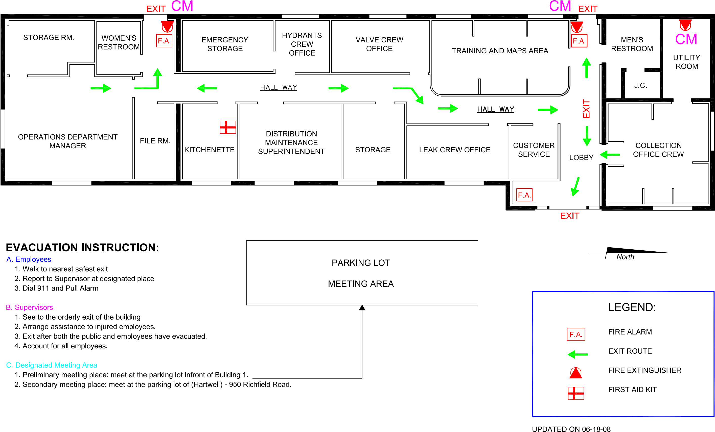
EVACUATION PLAN BLDG. 1

EVACUATION MAP

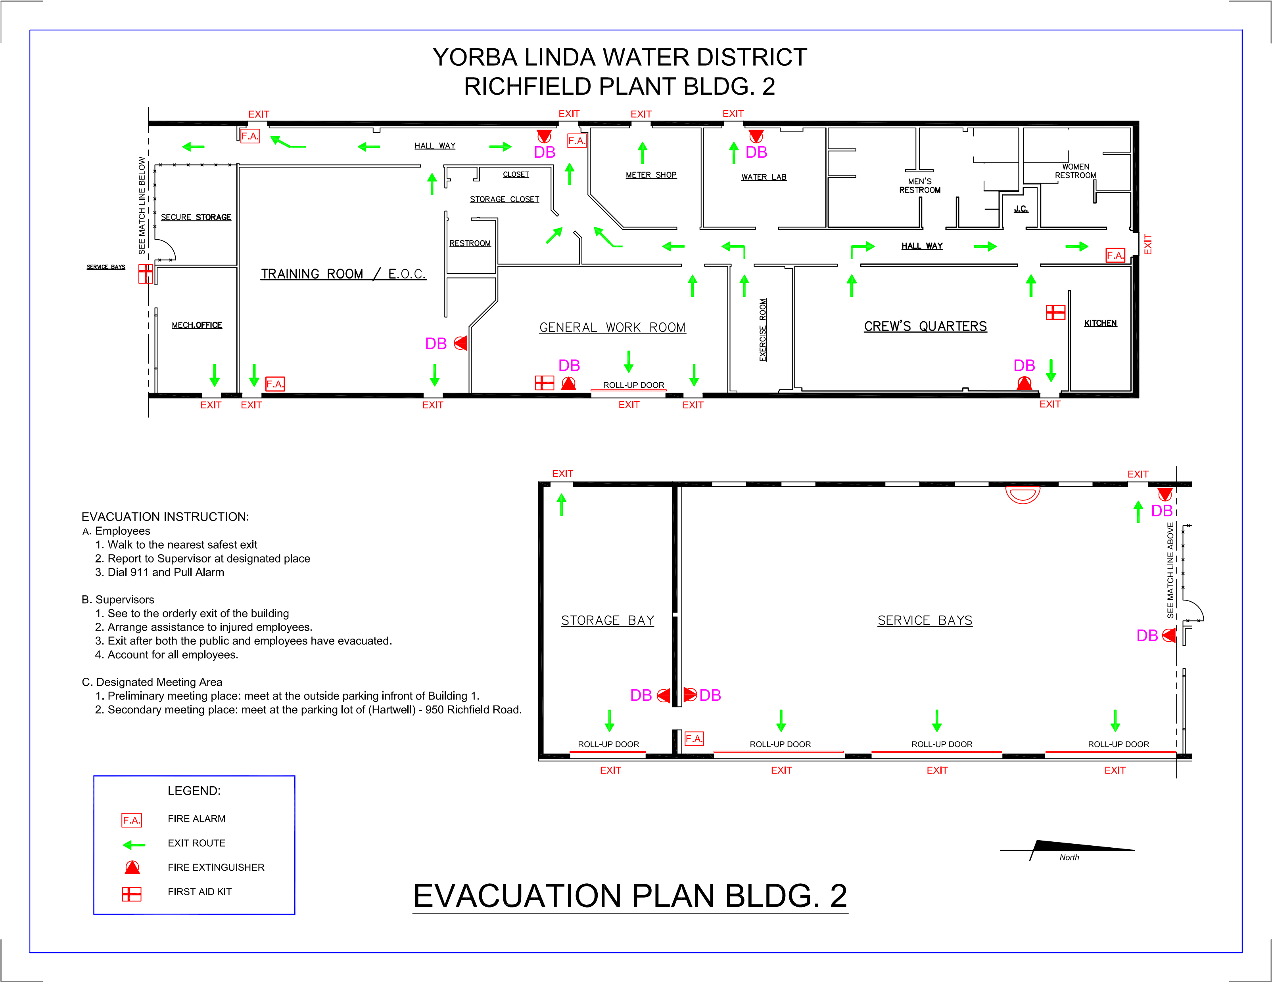

EVACUATION MAP

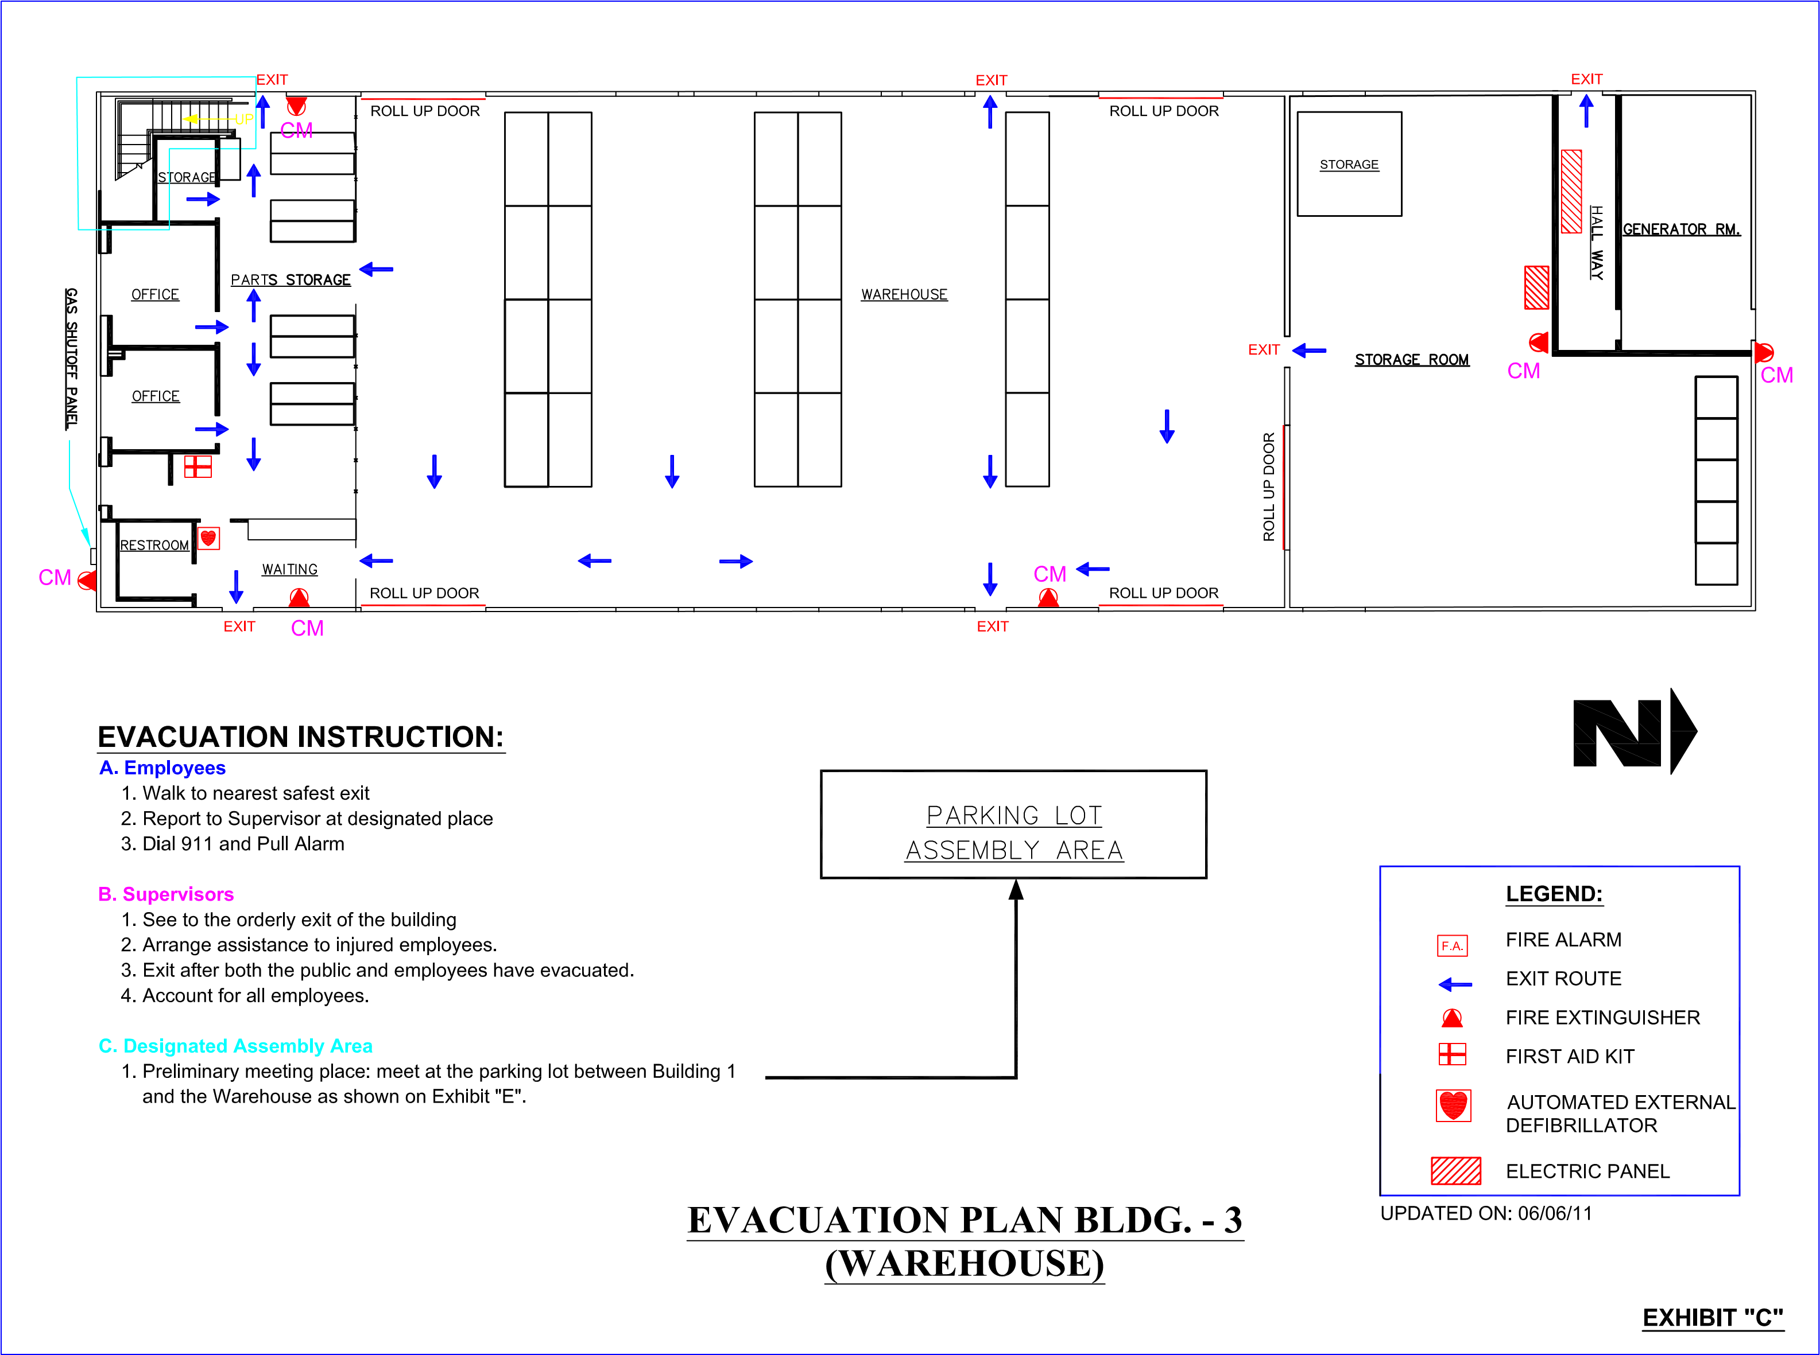

EVACUATION MAP

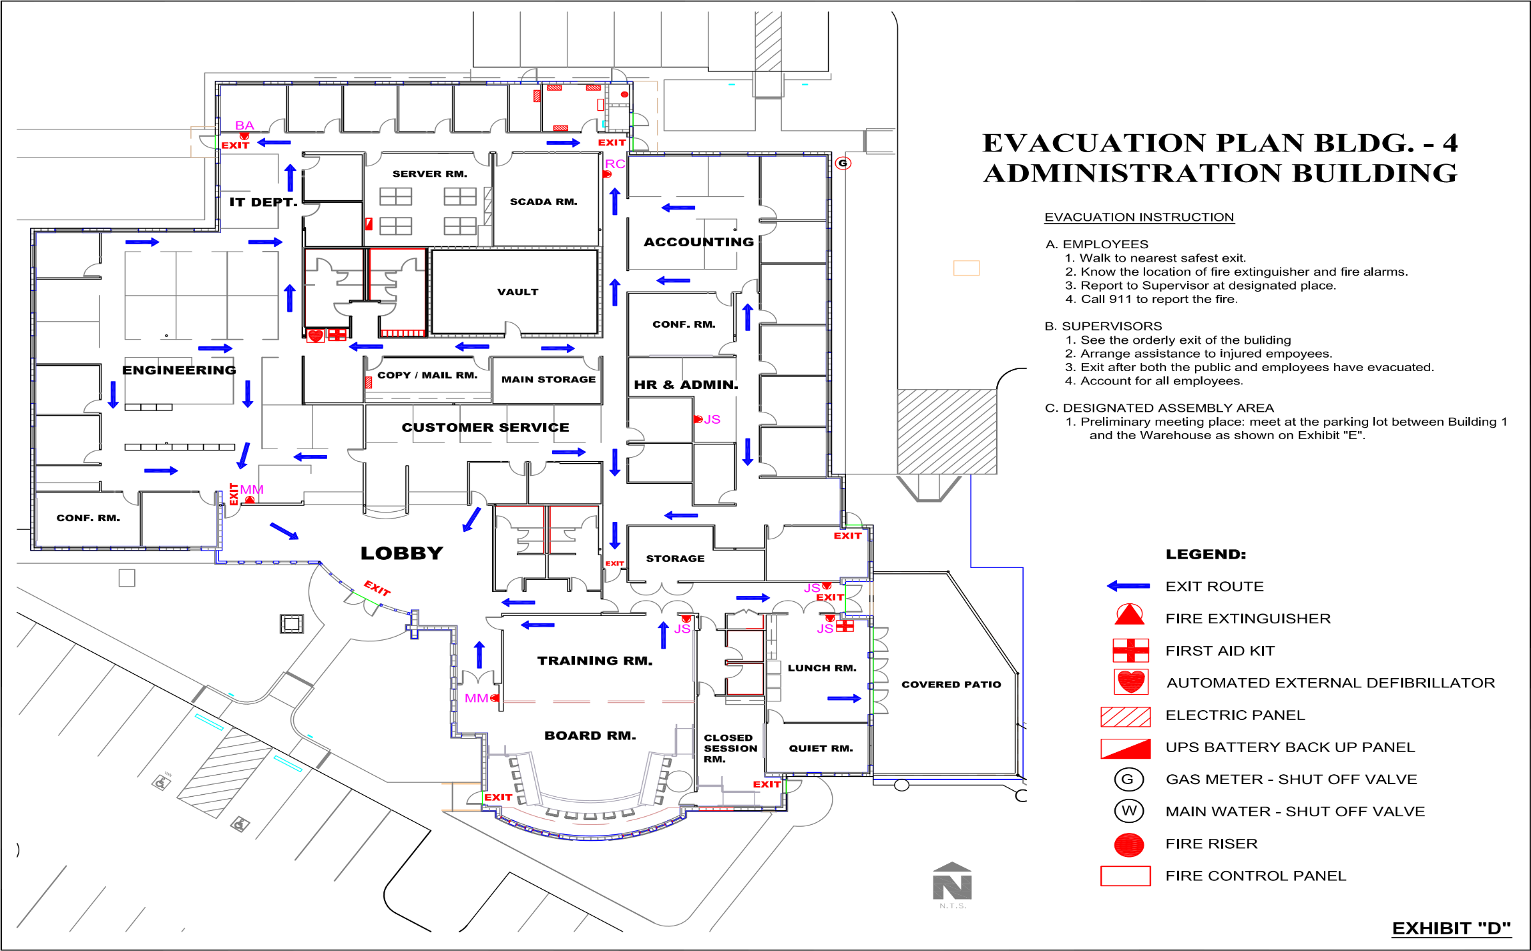
EVACUATION MAP

