Traffic Control Flagger
Authorization Form
This model form/template must be customized to meet your Agency’s needs.

_____________________________________________________ (name of individual)
has been designated as a Traffic Control Flagger by

______________________________________________________ (name of employer)
based on the individual’s training, experience, and demonstrated skills in the following:

Training requirements required by employer:
Flaggers shall be trained in the proper fundamentals of flagging moving traffic before being assigned as flaggers. Signaling directions used by flaggers shall conform to the CCR 1599 and California Manual on Uniform Traffic Control Devices (Manual). The training and instructions to be provided are:

- Initial training prior to assignment
- Reauthorization of Flagger every three years.
- Annual refresher training during department/toolbox trainings

Flagger Evaluation Date Evaluated/Passed by
- Understands flagger equipment which must be used _____ _____
- Wears proper Hi-Viz clothing based on speed/weather/work _____ _____
- Understands layout of the work zone and flagging station _____ _____
- Use proper methods to signal traffic to stop, proceed, or slow _____ _____
- Trained in methods of one-way traffic control _____ _____
- Demonstrates proper flagging methods during operations _____ _____
- Know how to guide emergency vehicles through the work zone _____ _____
- Understands procedures for handling emergency situations _____ _____
- Know methods of dealing with hostile drivers _____ _____
- Trained in methods of one-way traffic control (as applicable) _____ _____
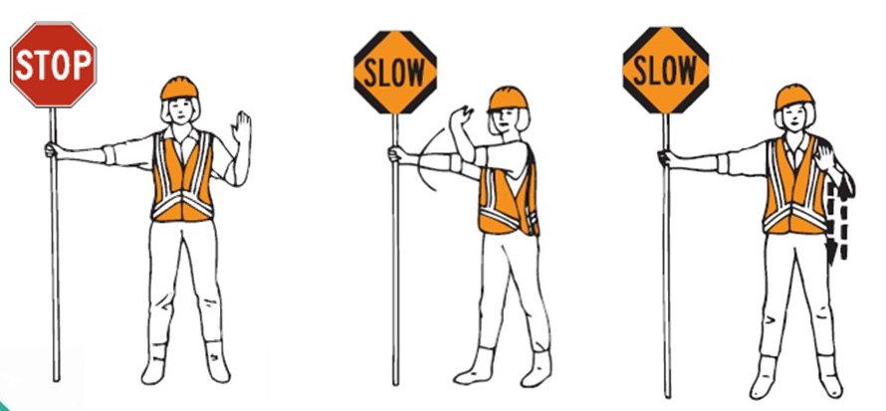
- Demonstrates flagging procedures when a single flagger is used _____ _____

STOP TRAFFIC RELEASE TRAFFIC SLOW TRAFFIC

Evaluated and Designated by:

Signature ____________________________________________________ Date ___________

Name ______________________________________ Title ____________________________

Signature of Individual Assigned as Traffic Control Flagger:

Name ________________________________Title ___________________ Date ___________

