Manhole Inspection Checklist

Manhole Number: ___________ Inspector: _____________________________
Manhole Barrier Diameter: ___________ Interceptor: _________________
Manhole Depth (Rim to Invert):___________________
This model form/template must be customized to meet your Agency’s needs.
Item Inspected | Date Inspected  (date each line that applies) |  |  | Repairs Needed  (√ each that applies) |  |  | Repairs Made | Date Repairs Made
COVER | Lift Pin | / / |  | Needs Pin |  |  |  | / /
 | Bolt Down | / / |  | Bolt Missing |  |  |  | / /
 | Locking | / / |  | Replace |  |  |  | / /
 | Non-Rocking | / /
CASTING | Badly Rusted | / / |  | Reset |  |  |  | / /
 | Knocked Loose | / / |  | Raise |  |  |  | / /
 | Good Condition | / / |  | Replace |  |  |  | / /
CHIMNEY | Brick | / / |  | Leaks |  |  |  | / /
 | Concrete | / / |  | Re-mortar |  |  |  | / /
 | Good Condition | / / |  | Replace |  |  |  | / /
 | Loose Mortar | / / |  |  |  |  |  | / /
 | Offset Opening | / / |  |  |  |  |  | / /
 | Center Opening | / / |  |  |  |  |  | / /
BARRELS | Good Condition | / / |  | Leaks |  |  |  | / /
 | Slight Corrosion | / / |  |  |  |  |  | / /
 | Bad Corrosion | / / |  |  |  |  |  | / /
BENCH | Grease Build-up | / / |  | Clean |  |  |  | / /
 | Bad Concrete | / / |  | Patch |  |  |  | / /
 | Good Condition | / / |  |  |  |  |  | / /
CHANNEL | Rocks in Channel | / / |  | Clean |  |  |  | / /
 | Grease Build-up | / / |  |  |  |  |  | / /
 | Bad Corrosion | / / |  |  |  |  |  | / /
 | Depth of Flow | / / |  |  |  |  |  | / /
 | Depth of Grit | / / |  |  |  |  |  | / /
INTER- | CHECK | YES | NO | Leaks
CEPTER | Lamped |  |  |  |  |  | Incoming Lines:
 | Loose Gaskets |  |  |  |  |  | Sketch location, note size,
 | Infiltration |  |  |  |  |  | and measure height
 | Slight Corrosion |  |  |  |  |  | of all incoming lines
 | Bad Corrosion |  |  |  |  |  | (from the pipe invert.)
 | Scratch Test
 | Scratch Depth |  | Inches
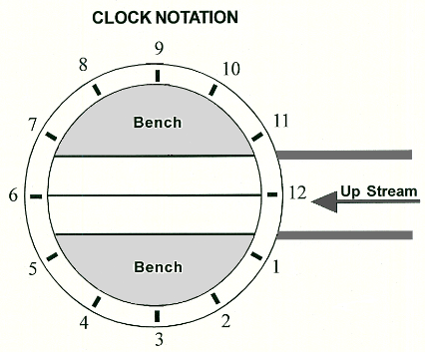
Additional Comments / Observations:

