Portable ladders are one of the most commonly used pieces of equipment in the construction industry. Accidents from portable ladders are very common. Falls are the most common cause of worker injury associated with ladder use. Cal/OSHA’s portable ladder etool cites the fall from ladders are mostly caused by the:

- Use of faulty ladders;
- Improper set-up of a ladder; or
- Incorrect use of ladders.

Portable ladder resources can be found on this Cal/OSHA webpage.

Best practices on portable ladder safety include design/construction, selection, inspection/maintenance, and training. Further information can be viewed on these Cal/OSHA etool webpages:

- Applicable Cal/OSHA standards
- Design and Construction
- Ladder Selection
- Inspection, Use and Maintenance
- Employee Training

Reference: Always refer to each ladder’s manufacturer’s operator manual/owner’s guide to determine a ladder’s design specification, inspection, use, maintenance, and PPE.

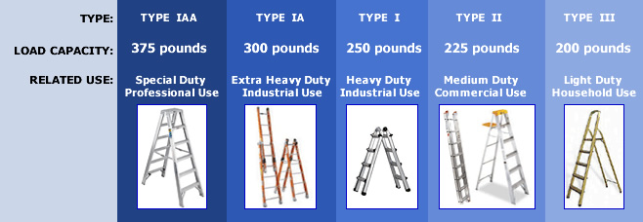

Photo Source: DOSH etool webpage

