



**Sewer Component Graphics**

**(Sketch/Notate Inspection Findings)**

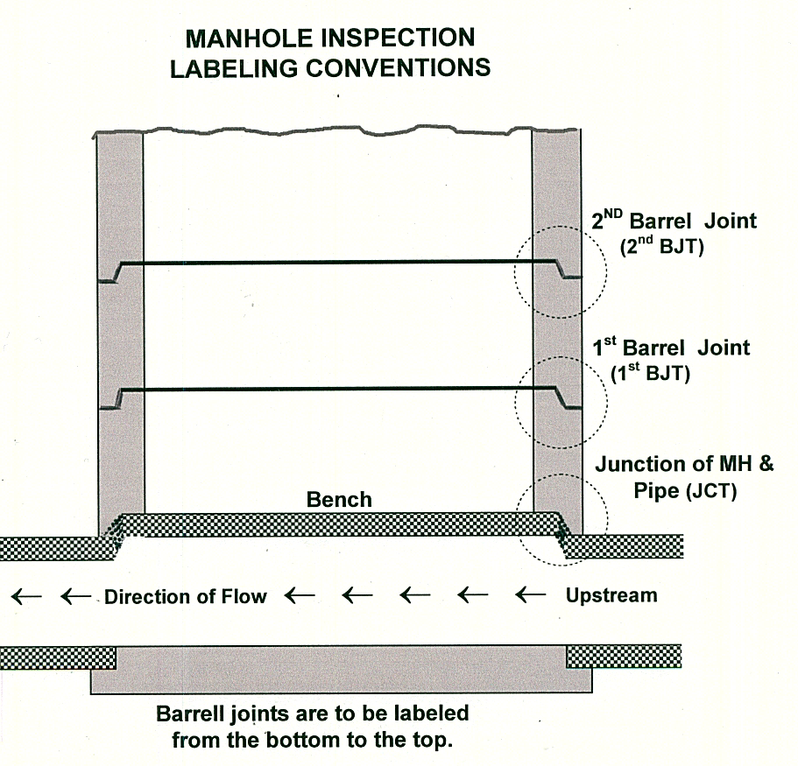

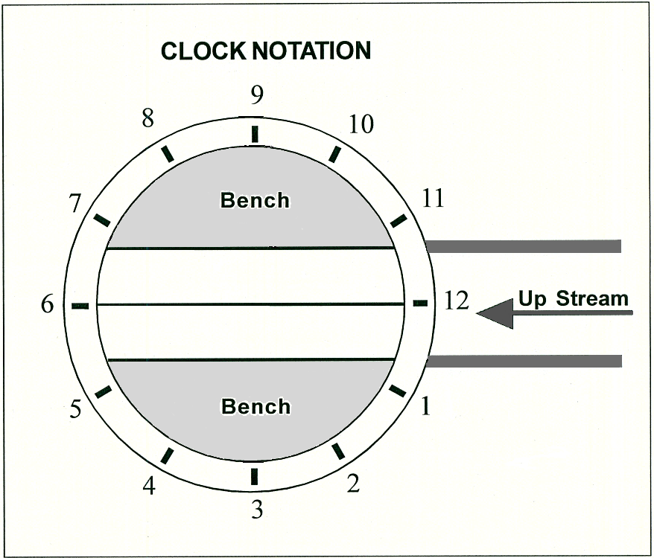

**This model form/template must be customized to meet your Agency’s needs.**