STANDARD OPERATING PROCEDURE (SOP)

PROCEDURE TITLE: VEHICLE PARKING & BACKING PROCEDURE

PURPOSE

This procedure establishes the safety measures to be followed by District personnel while parking and/ or backing all vehicles. The intent of this procedure is to prevent injuries and damage to property resulting from unsafe vehicle backing practices.

SCOPE

This procedure applies to all District vehicles.

PROCEDURES

Operator Responsibilities

The operator of any District vehicle is responsible for all actions of the vehicle and all personnel in the vehicle.

Operators will:

- Avoid backing whenever possible. When parking at a curb, allow sufficient clearance to pull out without backing. Avoid turning into any place where it is necessary to back into traffic. The operator's first option is to select parking locations where backing will not be necessary when leaving the site.

- Avoid getting into a position where a vehicle would be backed without a spotter. Whenever possible, choose pull-through parking spaces. If the vehicle can be driven forward when leaving, a backing accident may be prevented.

- Obtain guidance from a spotter to back a vehicle. If no spotter is available, get out and physically check the rear of the vehicle to ensure that it is clear. If the area is not safe for backing clear the area of people and objects, then back when it is safe to proceed.

- Determine conditions and clearances before backing a vehicle. Be alert and use caution while backing.

- Stop the vehicle while a spotter checks for obstructions on the blind side of the vehicle. Do not proceed until the spotter is visible. If these conditions cannot be met, an additional spotter will be required.

- Stop the vehicle immediately if the operator loses sight of the spotter.

Circle Check:

A. To improve safety and accident prevention, the District management has reviewed the benefits of establishing a "circle check" for all District vehicles.

B. The prevention of accidents can be enhanced by operators of vehicles placing suitable markers (traffic cones) at the back of the vehicle when parking.

Procedure:

- Operators of vehicles shall place at least one approved-fluorescent traffic cone at the front and rear of all vehicles and vehicle-trailer combinations. Exception: When parking in stalls where backing-only is required, operators are required to place one approved traffic cone at the rear of the vehicle.

- Operators of vehicles shall pick up the cones by making a complete circle check of the vehicle prior to driving away or backing up.

- Operators are responsible to ensure traffic cones are in place on the vehicle prior to starting out and returning from any assignments.

Operators shall not:

- Back into intersections or over pedestrian crosswalks. Such action is prohibited. Instead, where appropriate, operators should drive forward for a reasonable distance until a safe place to turn around without backing is located.

- Accept guidance from an employee while that employee is inside the vehicle.

Spotter Responsibilities

Spotters shall:

A. Render assistance to guide an operator in backing a vehicle when requested by the operator.

B. While giving guidance in backing a vehicle, stand on the ground at the rear driver's side of the vehicle whenever possible. Spotters must stand far enough behind the vehicle to observe the backing path and any obstructions, including pedestrians, and to allow for sufficient stopping distance in an emergency.

C. Use hand signals to communicate to the operator backing a vehicle. Do not rely solely on voice communication for this purpose.

D. Remain in clear view of the driver at all times. Spotters will refrain from moving back and forth behind the moving vehicle.

Supervisor Responsibilities

Supervisors shall:

A. Inform affected employees about the District's Vehicle Parking & Backing procedure and of their responsibilities under the policy.

- Ensure that operator and spotter employees comply with the requirements of this policy.

Authorized by:
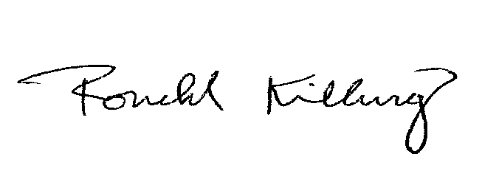
1/23/2013
Ronald Kilburg Date
Safety/Security Officer

